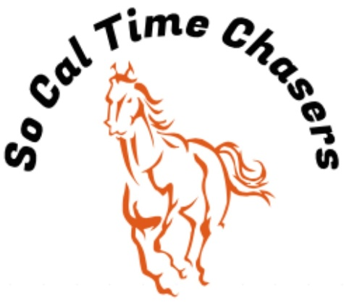
Board Meeting Minutes for
04/10/25

Location | In Person
Meeting called to order | 3:20 pm PST
Members in attendance
X | President: Bob Cranor
X | Vice President: Charla Cranor
X | Secretary: Shannon Cannon
X | Treasurer: Jessica Manning
X | Director at Large: Colby Manning
 | Director at Large:
 | Volunteer Coordinator: TBD
 | Awards Coordinator: Charla Cranor

Agenda
Old business: None

Treasure Report:
Current Assets: $5153.04
Checking: $5153.04
TOTAL ASSETS: $5153.04

Show income: $1226
Venmo $762
Paypal $0
Show Deposit $282
Show Expenses $1158.20
Show Net $67.80

The club still owes Cranor Family $1000 for arena fee they had to pay in advance for the Jan Show and $900 for the water truck and supplies bought fix water truck.

Colby moved to approve the treasure report, Charla seconded it and all board approved.

- Recap Show: April 5th Show - 18 riders
- We had no time writing issues at this show.
- Pink sheets were posted on website

- CGA State Business:
- Need to see if anyone is interested in going to the Southern Spring Classic or the State show

  - State show dates: 19-25 July Bolado Park
  - Spring Classic – Tehachapi @ Yellow Rose Ranch 23-26 May

- New Business:
  - Additional A Div Buckle order has been placed.
  - Water truck might not be working for the next show
  - Board agreed to change out KH for F8S since there was also Hurry Scurry and F8F at the next show.
  - Charla moved to have an end of year catered BBQ at the last show in June with a max club out of pocket expense of $1500. Bob seconded the motion.

Charla moved to adjourn. Colby seconded it. Meeting ended at 3:46pm

