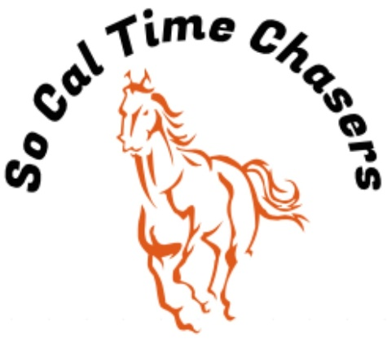
Board Meeting Minutes for
02/26/25

Location | In Person
Meeting called to order | 5:00 pm PST
Members in attendance
X | President: Bob Cranor
X | Vice President: Charla Cranor
X | Secretary: Shannon Cannon
X | Treasurer: Jessica Manning
X | Director at Large: Colby Manning
 | Director at Large:
 | Volunteer Coordinator: TBD
X | Awards Coordinator: Charla Cranor

Agenda
Old business: None

Treasure Report:
Current Assets
Checking: $6474.83
TOTAL ASSETS: $5101.01

Show income: $1634
Venmo $976
Paypal $0
Show Deposit $557
Show Expenses $1272.97
Show Net $361.03

The club still owes Cranor Family $1000 for arena fee they had to pay in advance for the Jan Show and $900 for the water truck and supplies bought fix water truck.

Shannon moved to approve the treasure report, Bob seconds it and all board approved.

- Recap Show: Feb 22 Show - 26 riders
- We had no time writing issues at this show.
- Dirt is showing signs we could make good times on events. This show 3 arena records were broken.
- Pink sheets were posted on website
- Initial issue with F8S and had to move the event over and restart this event. We will watch out for this for F8S and F8F events in the future to ensure they don’t end up so close to the arena fence.

- CGA State Business:
- Need to see if anyone is interested in going to the Southern Spring Classic or the State show

  - State show dates: 19-25 July Bolado Park
  - Spring Classic – Tehachapi @ Yellow Rose Ranch 23-26 May

- New Business:
  - Buckle series March/April and maybe May/June.
  - Buckle order has been placed.
    - Shannon moved to split the A Division for the Buckle Series and buy an additional A buckle. Charla Seconded the motion.
  - Charla has ordered the awards for the March Show
  - Water truck might not be working for the next show

Charla moved to adjourn. Jessica seconded it. Meeting ended at 5:27pm

