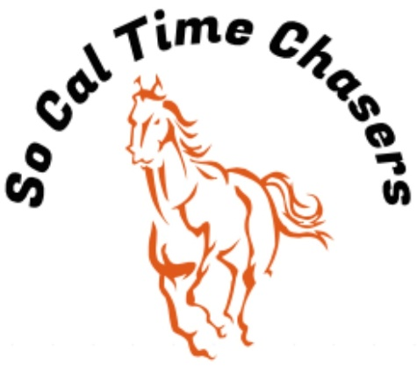
Board Meeting Minutes for
05/14/25

Location | In Person
Meeting called to order | 5:41 pm PST
Members in attendance
X | President: Bob Cranor
X | Vice President: Charla Cranor
X | Secretary: Shannon Cannon
X | Treasurer: Jessica Manning
X | Director at Large: Colby Manning
 | Director at Large:
 | Volunteer Coordinator: TBD
 | Awards Coordinator: Charla Cranor

Agenda
Old business: None

Treasure Report:
Checking: $6074.47
TOTAL ASSETS: $5239.97

Show income: $1670
Venmo $862
Paypal $0
Show Expenses $1024.50
Show Net $645.50

The club still owes Cranor Family $1000 for arena fee they had to pay in advance for the Jan Show and $900 for the water truck and supplies bought fix water truck.

Shannon moved to approve the treasure report, Charla seconded it and all board approved.

- Recap Show: May 10th Show - 24 riders
- We had no time writing issues at this show.
- Pink sheets were posted on website.
- Had printer issues with printing at the show. Was able to fix the driver issue that evening.
- The PA System got too hot so we need to watch this in the future.

- CGA State Business:
- Need to see if anyone is interested in going to the Southern Spring Classic or the State show

- State show dates: 19-25 July Bolado Park
- Jessica verified that the $100 has been sent to state.
- Spring Classic – Tehachapi @ Yellow Rose Ranch 23-26 May

- New Business:
  - Additional A Div Buckle order has been placed.
  - Water truck is going to get fixed
    - Estimated cost is $1800
    - Charla moved to take the $600 owed to them for the water truck to pay towards fixing the water truck. Jessica seconded it and all board approved.
  - Board agreed to change out HS for SS due to the heat
  - Charla moved to have an end of year catered BBQ at the last show in June with a max club out of pocket expense of $1500. Bob seconded the motion.
  - Next Year’s Show Dates are:
    - Sept 20
    - Oct 18
    - Nov 15
    - No Dec Show
    - Jan 24
    - Feb 21
    - Mar 21
    - April 18
    - May 16
    - June 20

Charla moved to adjourn. Colby seconded it. Meeting ended at 6:09pm

