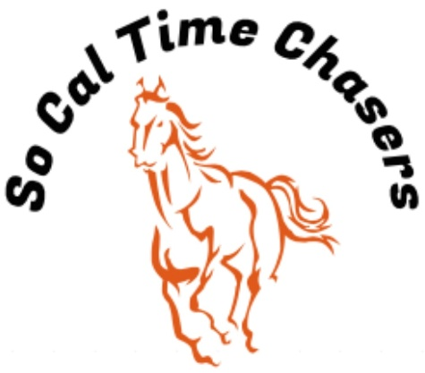
Board Meeting Minutes for
09/25/25

Location | In Person
Meeting called to order | 5:06 pm PST
Members in attendance
X | President: Bob Cranor
X | Vice President: Charla Cranor
X | Secretary: Shannon Cannon
X | Treasurer: Jessica Manning
 | Director at Large: Colby Manning
 | Director at Large:
 | Volunteer Coordinator: TBD
 | Awards Coordinator: Charla Cranor

Agenda
Old business:
Recap Show: Sept 20 show - 24 riders looked like all had a good time
- We had no time writing issues at this show.
- Dirt seems to be good received 2 plus times .
- Received a donation of $500 from David and Diane Welgel, thank you on web site
  - Bob moved to used this donation to fix the arena watering system. Charla seconded it.
- Prestigious Building Solutions is donating buckles for Oct- Nov shows need Flyer to send out
- Pink Sheets were posted on the website
- Drew and Bob have a plan to fix the hitching post Drew ran over

Treasure Report:
Current Assets
Checking $4398.71
TOTAL ASSETS $4011.71
Show income $1752
Venmo $1082
Paypal $0
Cash/Checks $670
Show Expenses $1336.88
CGA $387
Jackpots $170
Arena $500
Awards $279.88
Show Net $415.12

- Club sent the $387 and $100 for the State show via VENMO tonight
- Shannon moved to approve the treasure report, Charla seconded it and all board approved.
CGA State Business:
- Need to see if anyone is interested in going to the Jamboree at dist. 40 State show

New Business: None

- Jessica moved to adjourn. Charla seconded it. Meeting ended at 5:24pm

