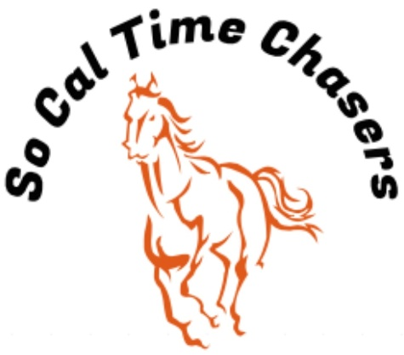
Board Meeting Minutes for
10/30/25

Location | Virtual Meeting via e-mail
Meeting called to order
Members in attendance
X | President: Bob Cranor
X | Vice President: Charla Cranor
X | Secretary: Shannon Cannon
X | Treasurer: Jessica Manning
X | Director at Large: Colby Manning
 | Director at Large:
 | Volunteer Coordinator: TBD
 | Awards Coordinator: Charla Cranor

Agenda
Old business:
Recap Show: Oct 18 show - 24 riders a few new ones this show
- We had no time writing issues at this show.
- Thank you to Equine Services for letting us use the tractor and her new water truck to prep the ground Friday.
- Dirt seems to be good we had a new HS Arena record set by Bob Cranor with a 10.458
- Prestigious Building Solutions donated buckles for Oct- Nov shows. Buckles are in
- Pink Sheets were posted on the website
- Drew and Bob have a plan to fix the hitching post Drew ran over

Treasure Report:
- We will approve the treasurer report separately since we are not meeting in person
- Club will be sending $180 for membership dues, $505 for state awards program and $204 for the rides for a total of $889.00 going to the CGA State office.

CGA State Business:
- Nov 15-16 Is State Convention. Bob, Charla, Shannon, and Andy will be there. Charla is running for Board of governors and she is the club delegate for this meeting as well.
- Darrielle Ruyle sent an e-mail giving the club permission to pick up Reagan Ruyle’s awards at convention. I have forwarded that e-mail to Marnie.

New Business:
- Molly’s Custom Silver has posted their Black Friday Special of $69.70 per buckle. Charla has motioned for the club to buy enough for the next Buckle Series this Spring. Shannon has seconded it. Any objections from the other board members?
- With having more than 8 riders signed up for the state awards I looked and there might be a few events we should switch around in future shows in order to help those riders make sure they get a chance to make their rides needed. I know they can always request setups as well. Here is what I counted we are scheduled to run for the year.
  - Barrels: 6
  - Quad: 3
  - P1: 5
  - P2: 4
  - F8F: 3
  - F8S: 3
  - HS: 2
  - Speedball: 6
  - Birangle: 3
  - BigT: 6
  - Speed Barrels: 6
  - SS: 5
  - Keyhole: 2

