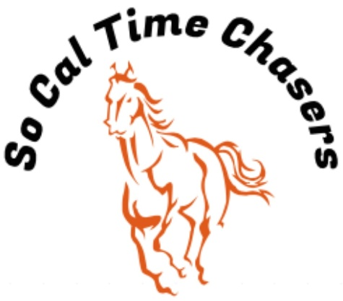
Board Meeting Minutes for
3/6/26

Location | Cranor House
Meeting called to order | 9:04am
Members in attendance
X | President: Bob Cranor
X | Vice President: Charla Cranor
X | Secretary: Shannon Cannon
X | Treasurer: Jessica Manning
X | Director at Large: Colby Manning
 | Director at Large:
 | Volunteer Coordinator: TBD
 | Awards Coordinator: Charla Cranor

Agenda
Old business:
Recap Show: Jan 21 show - 28 riders a few new ones this show
- We had no time writing or any other issues at this show.

Recap Show: Feb 21 show – 31 riders a few new ones this show
- We did have a time writing issues at this show. Shannon noticed that a time was written for her when it should have been a no time. Solution moving forward will be to have Jessica or Beth at the booth with them to ensure everyone has been trained and paying attention during the runs.
- The ground was definitely slower for the fast riders
- We had a person that we had to talk to that had unprofessional behavior toward other members at the show. The So Cal Board Members will monitor the situation moving forward to ensure that this behavior does not continue.

Treasure Report:
- Shannon moves to approve the treasurer report and Charla seconds it
- Registration of charities $50
Current Assets (Checking) $4863.10 ($1,000 was donated to go for arena watering system installation)
Show income $2185
Venmo $1306
Cash/Checks $879
Show Expenses $1577.79
CGA $630.00 Jackpots
Show Net $607.21

CGA State Business:
- Southern Classic: 22-25 May
- State Show: 17-24 July
- State got new implements for the state show

New Business:
- Scholarships: We received a scholarship request from Reagan Ruyle. We are going open it up to everyone and have a deadline of 27 March for those letters.
- We need to let the riders who signed up for State Awards that we can do setups after the show for those who need it.

Charla moves to adjourn at 9:30 and Jessica approves the motion.

