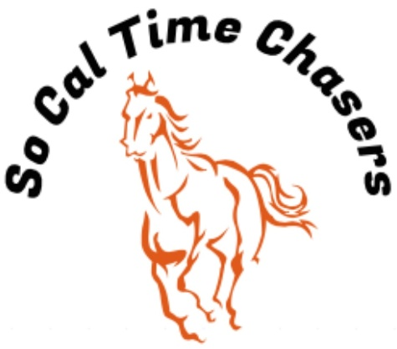
Board Meeting Minutes for
4/26/26

Location | Cranor House
Meeting called to order | 5:00pm
Members in attendance
X | President: Bob Cranor
X | Vice President: Charla Cranor
X | Secretary: Shannon Cannon
X | Treasurer: Jessica Manning
X | Director at Large: Colby Manning
X | Director at Large: Drew Mascari
 | Volunteer Coordinator: TBD
 | Awards Coordinator: Charla Cranor

Agenda
Old business:

Recap Show: April 18 show – 31 riders a few new ones this show.
- Time writer – No issues this past show
- 2 accident reports sent in with the show paperwork.
- Had an issue with a horse getting hurt stepping into a gopher hole. We are going to try to get them taken care of to prevent this in the future. The board all agrees to give the rider show credit for the next show since it happened after the 2nd event.
- Bob installed the shut off valve and sprinkler system prior to this show. We still have ~$600 of the donated money to spend. Drew volunteered to get with his vendor to get a quote for qty 4 more sprinklers. Once he and Bob have a total price, we asked them to text the board if they needed to spend more than the $600 remainder that is set aside for this project.

Treasure Report:
- Charla moves to approve the treasurer report and Drew seconds it.
- Current Assets (Checking) $6291.77 ($1,000 was donated to go for arena watering system installation)
Show income $1961.00
Venmo $911
Cash/Checks $895
Show Expenses $1256.17
CGA $384.00
Show Net $704.83

CGA State Business:
- Southern Classic: 22-25 May
- State Show: 17-24 July (State Show Entries Come out 1 May)

New Business:
- Board agreed to cater the last show in June with BBQ. Jessica provided a quote for the guy we used last year for $1500 for 80 people. Drew is also going to get a quote from a friend of his. Once we get that the board will vote on which to go with.

Charla moves to adjourn at 5:20 and Drew approved the motion.

